**Detail report**

* **Abstract:** Summery reports with graphic are important for district administrator. Report using graphic and advance visualize tool, would allow administrator to gain clear picture of district at a glance and may also be displayed the graphical representation on distract web portal which fetch, analyze and visualized data in advance graphical format dynamically.

Google Charts may very useful for data visualization.

* **Problem Statement: G**raphical report of district at a glance in a dynamic way is not possible because of lack of synchronization among websites.
* **Proposed technology selected for application:** PHP, MySQL, Google Charts , The R Project for Statistical Computing or other advice tools.
* **Solution Description:**
  1. **Data Collection:** At fast collect the data for various e-district automated applications and websites.

**Mode of Collection:**

* + 1. May collect data from applications/web portal using web service if permissible which will be structured data.
    2. May read/extract data from reports generated by various e-district applications/web portals using PHP to insert it in a database.

# Statistical Computing and Data Visualization:

# Google chart tools are powerful, simple to use, and free. Google chart tools provide a variety of charts designed to address data visualization needs. These charts are based on pure HTML5/SVG technology so no plugins are required. Just need to load the Visualization API and the core chart package, set a callback to run when the Google Visualization API is loaded and call functions. Load the AJAX API may be loaded using inbuilt js.

# Send parameters or may create array using MySQL database which may populate directly using entry form or using web service. Pass the created array to chart.draw function after creating chart object. The object may be created for which revert graphical /visual representation of the data or may do the same using other advice graphical tools which are available.

* **Innovation:** Summarization and visualization of abstract data.

Example : Expenditure Statement of District Magistrate Office-Alipurduar, W.B

* **Target User Group:** District Administration and/or citizen using web portal.
* **Target Sector:** District
* **Impact on Citizens and on District Administration:**
  + 1. It gives the most accurate picture of a district at a glance.
    2. Statistical and graphical report, on which officials planning can be based upon.
    3. District administrator can take proper actions/initiatives based on the summarized data visualization.

This is developed by PHP and MySQL. It shows a chart view of “Expenditure Statement of District Magistrate Office-Alipurduar,W.B” dynamically. This application used to fetch data from table to graphical form.

Every part can be elaborate by click. As for example, graph.php shows Expenditure for salary is 0.9% (Please refer Figure 1.1). Salary details may be viewed by clicking on salary sectors (Please refer Figure 1.2). sectors of salary sector are Basic,GP,TA,HRA.

Graphical form may be Pie Chart, Column Chart, Bar Chart, Line Chart etc.

**Figure 1.1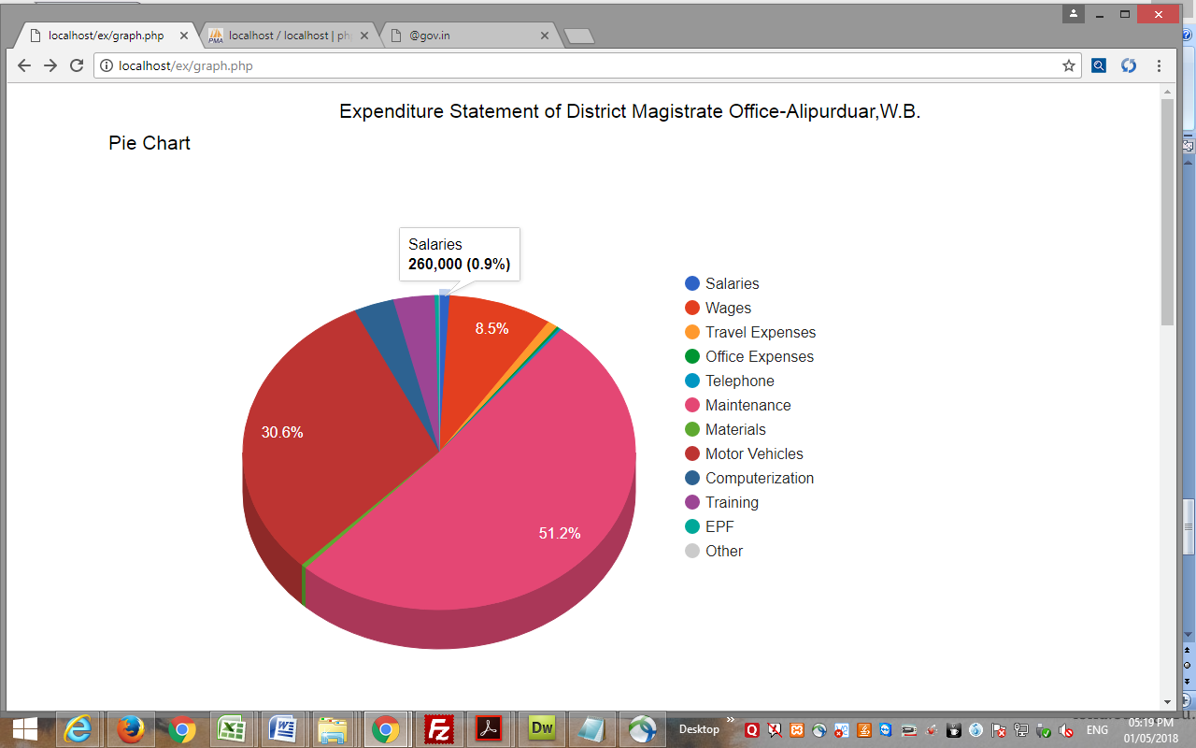 Figure 1.2**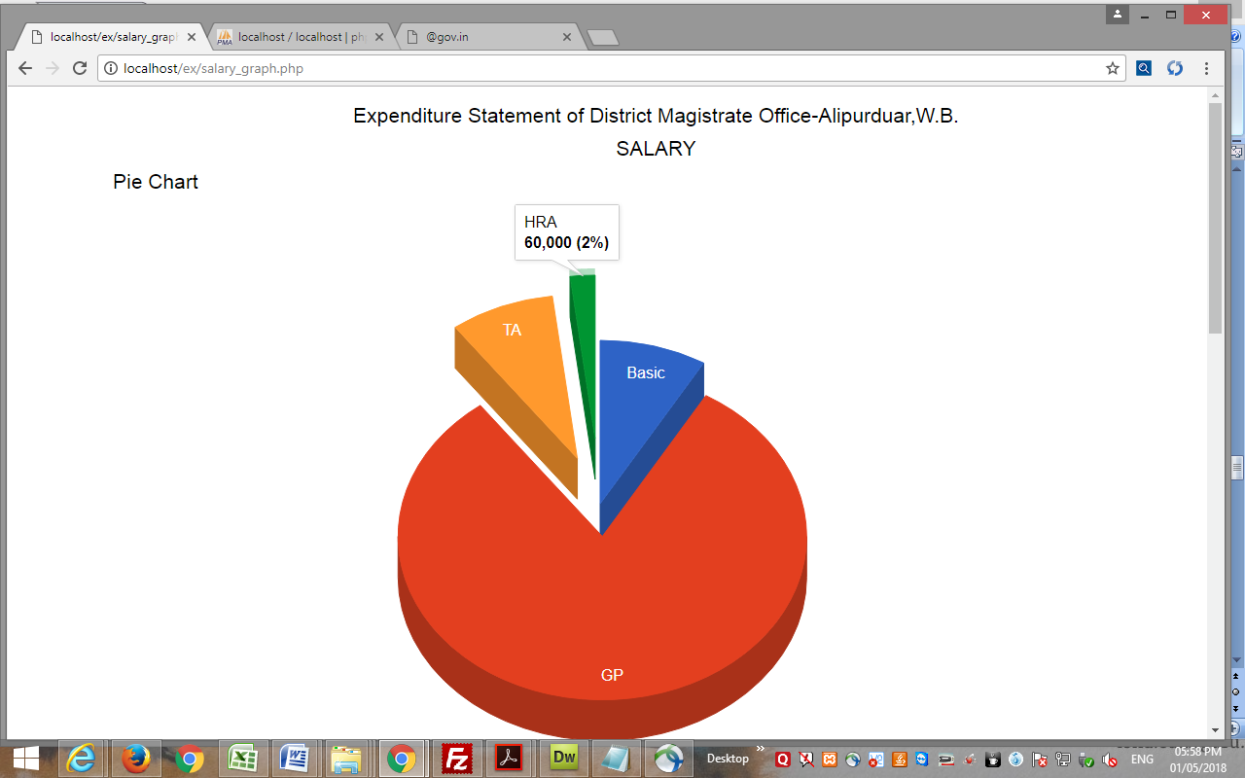

**Figure 1.3**

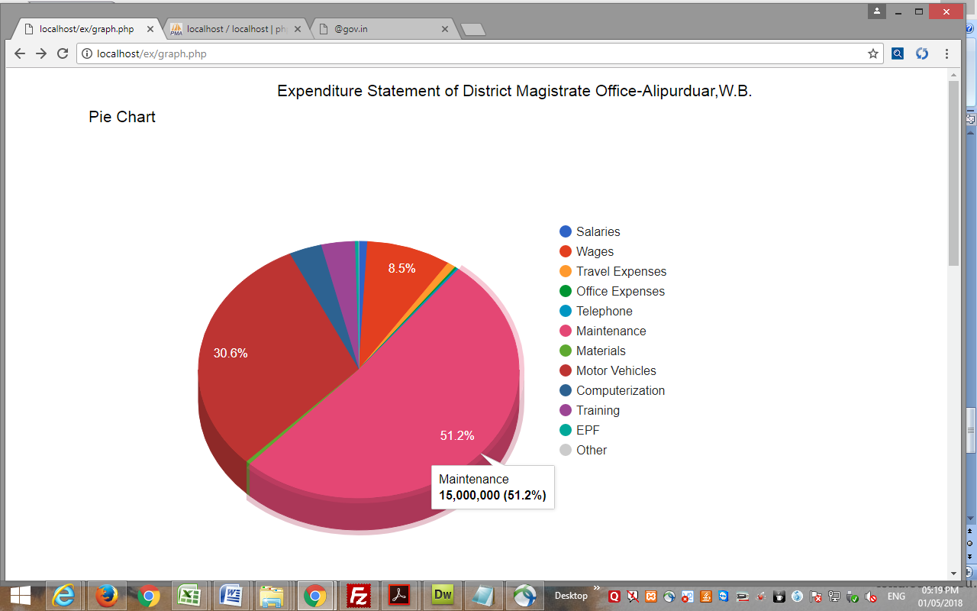

**Figure 1.4**

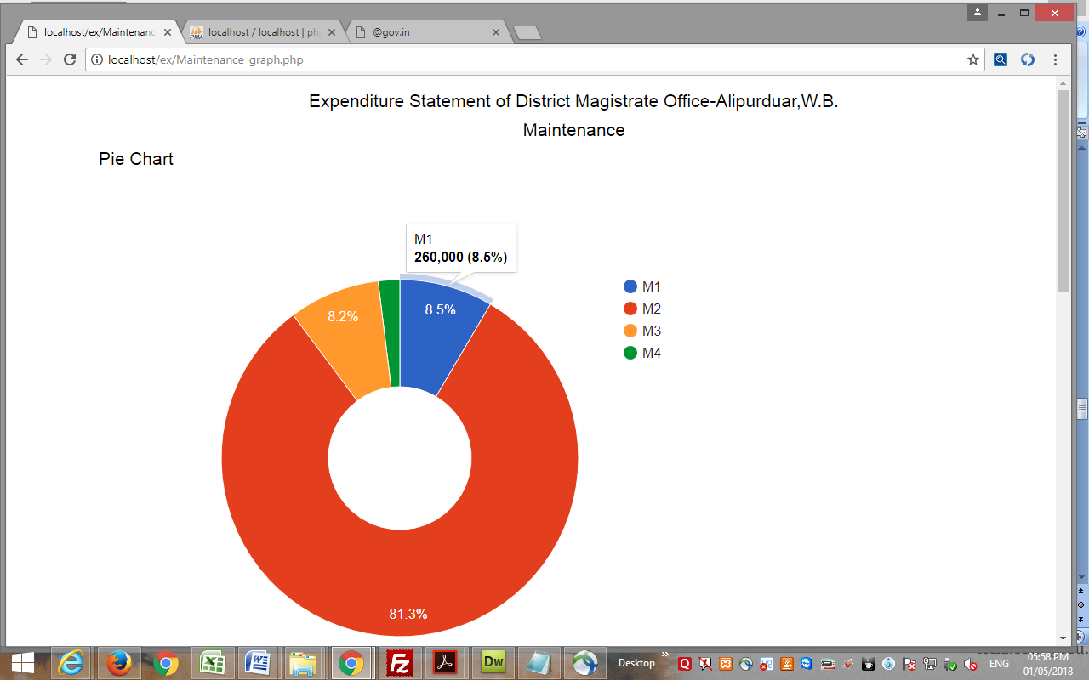

**Figure 1.5**

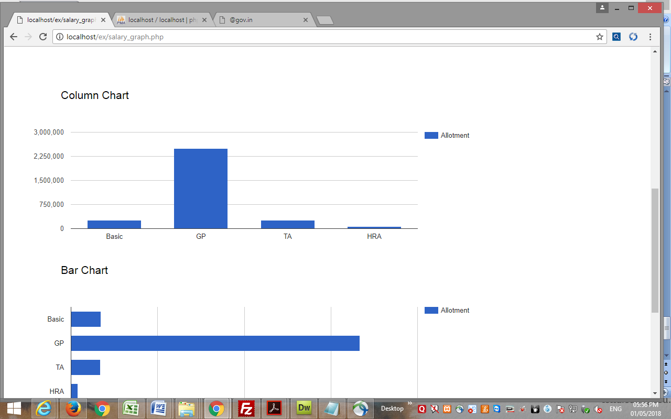 **Figure 1.6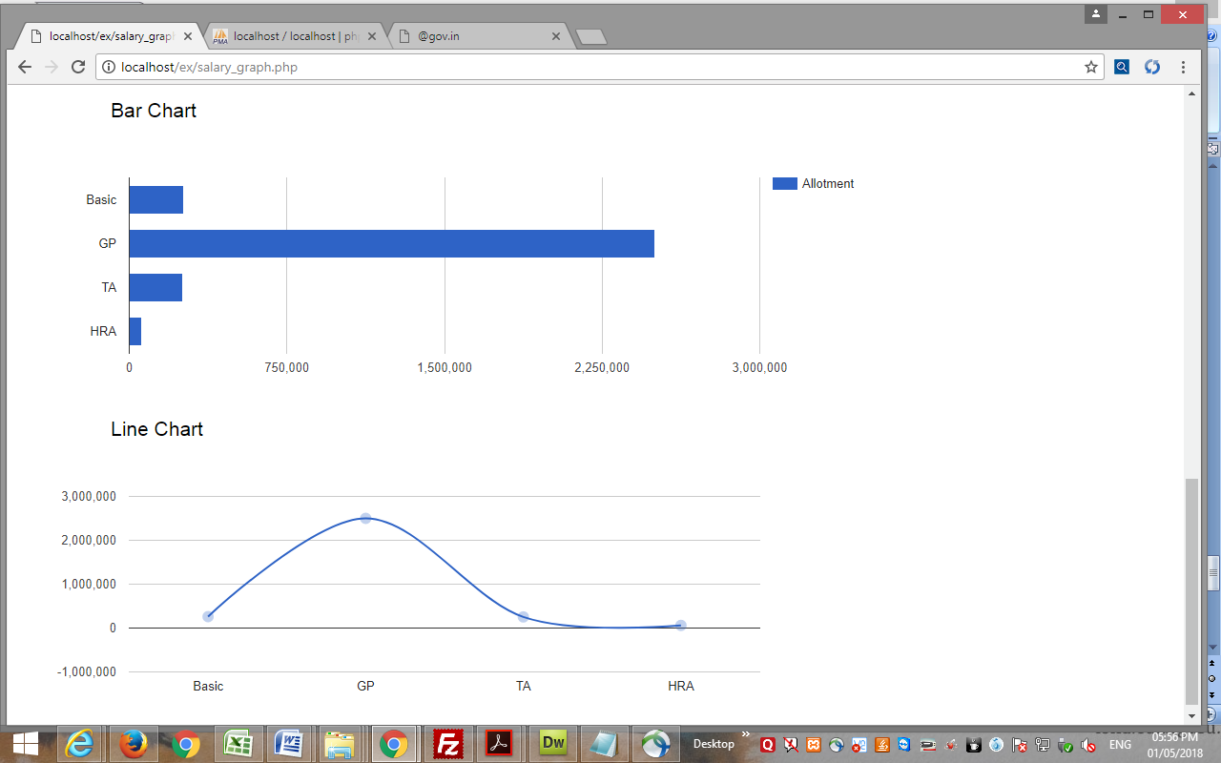 Figure 1.7**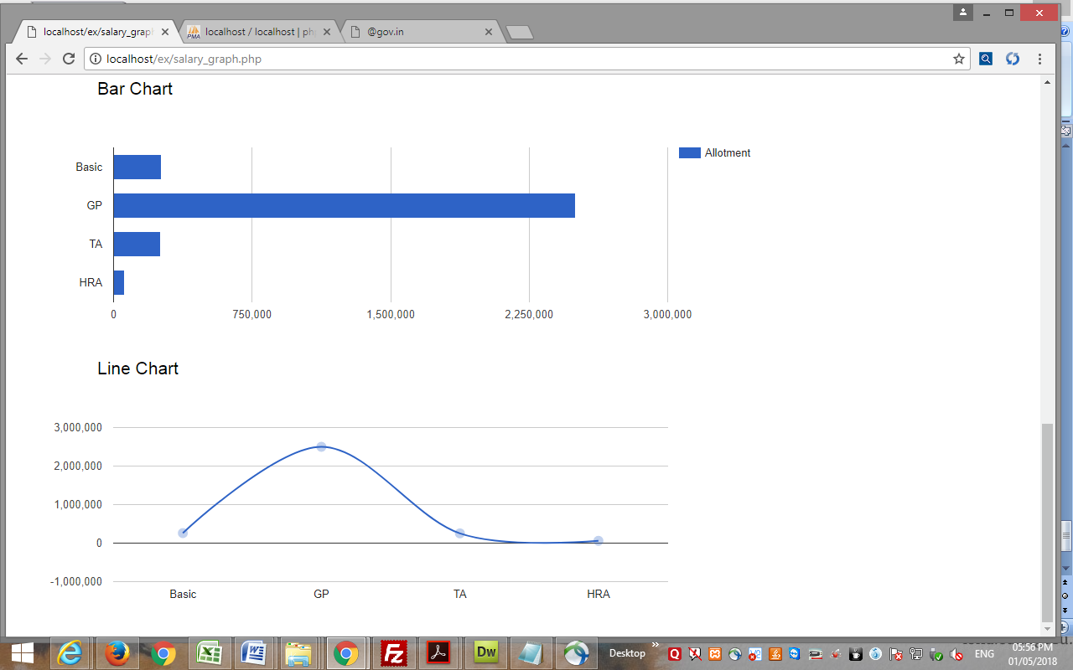

**Figure 1.8**

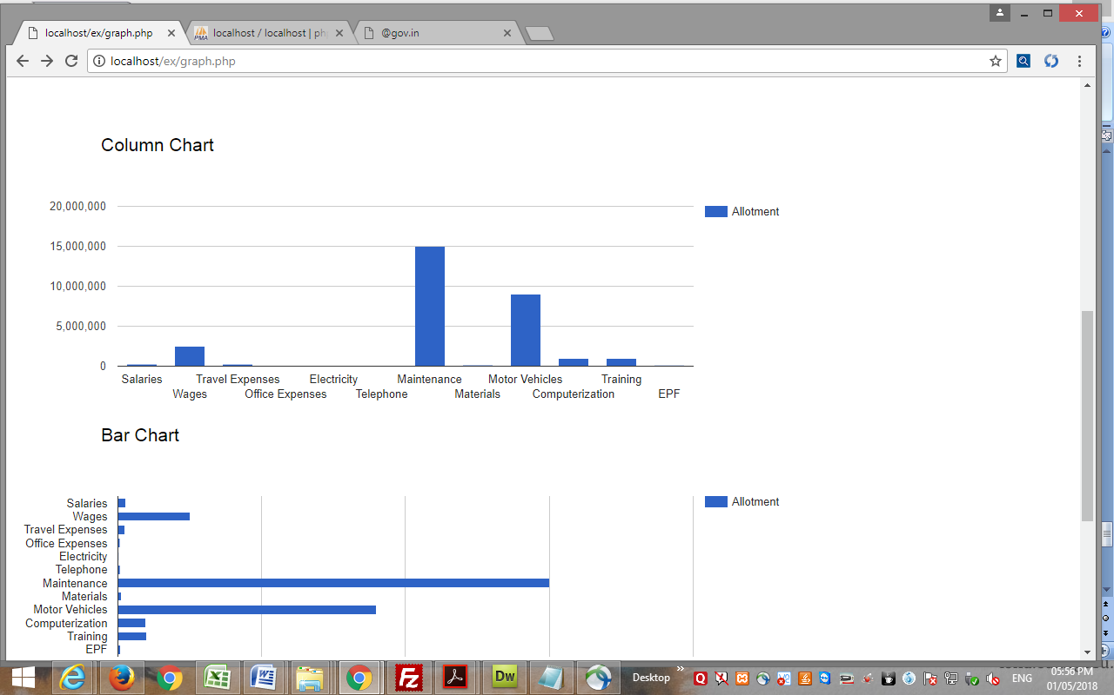

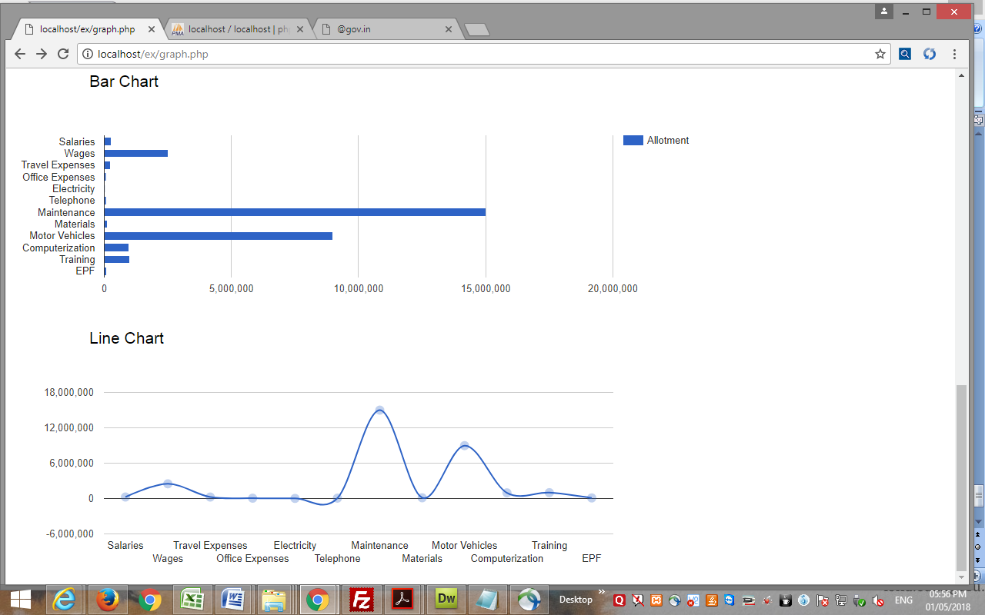

**Submitted by:**

**Mrinmoy Chakraborty(6496),**

**SO-SB & DIO,**

**NIC- Alipurduar,W.B.**